Visual Verification
A Conceptual Overview

General Notes
Visual Verification (VV) verifies whether screen content (a snapshot) is within the tolerances of a reference snapshot. The core VV terminology is:
- Snapshot: A pixel buffer used for representing and evaluating screen image data.
- Verifier: An oracle object which determines whether a snapshot passes against specified inputs.
- Actual: The snapshot being evaluated.
- Master: The reference data (image) which is used to evaluate the actual snapshot.
- Tolerance: The accepted bounding range based on which the actual snapshot will be accepted as valid.

Verifier Technology
TestApi provides the following Verifier technology:
- SnapshotColorVerifier. Reports passing if an image is within a user-specified tolerance range of a target color.
- SnapshotHistogramVerifier. Reports passing if the histogram of the image falls under the curve of a reference image histogram. This technique is helpful for allowing small quantities of noise pixels in an image that is otherwise identical to the master image.

Example
The basic scenario for Visual Verification is to capture window content and compare it against a known image. The diagram below outlines the overall sequence, as executed in the VisualVerificationTest class of the SampleAppTest project:
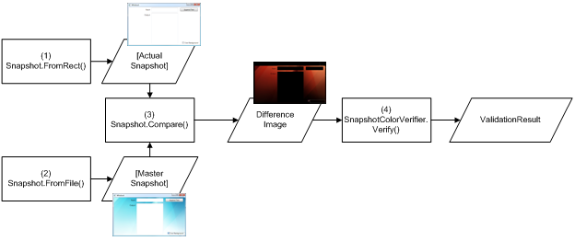
Figure 1 - Sample Visual Verification workflow
The steps for performing the workflow are outlined in the following procedure.
- Capture a screenshot of the actual window. This is done by capturing a snapshot of the window or control of interest:

// Capture the actual pixels from the bounds of the screen rectangle
Snapshot actual = Snapshot.FromRectangle(windowRect);

- Load a master image to judge the captured image against:

// Load the reference/master data from a previously saved file
Snapshot master =
Snapshot.FromFile(Path.Combine(TestContext.TestDeploymentDir, "Master0.png"));

- Compare the images, which creates a difference image. Any regions which are identical in the actual and master images appear as black; areas with significant differences are shown in other colors, which makes them prominent. This makes it easy to assess differences between the actual and master image during failure analysis.

// Compare the actual image with the master image
Snapshot difference = actual.CompareTo(master);

- After the difference image has been created, verify it to see whether the object meets standards. The ValidationResult object reports this outcome.

// Configure the snapshot verifier - It expects a black image with zero tolerances
SnapshotColorVerifier colorVerifier =
new SnapshotColorVerifier(Color.Black, new ColorDifference());

// Evaluate the difference image
VerificationResult result = colorVerifier.Verify(difference);

